Bruce Cowie War Diary – from posting to Blakehill Farm

March lst (Wed.)
Posted 233 Sq'n BlakeHill Farm.

March 2nd (Thurs.)
3 days leave - left for London 2.25 pm train. - night John (*1) - Win in pub - Clapham.

March 3rd (Fri.)
- Garrick Hotel - East Grimstead with Harold - see Tom Browne - evening in Chandos - Ron, Bob Want, George Royes, Neil Guthrie (in civies!) Harold - Paulette (Ins) lot fun - Lyons' Corner House - feed - tube - bus back eventually reached Garrick.

March 4th (Sat.)
Brighton Train - Star l Garter Hotel - "Savoy" - "Lassie Come Home" - pubs.

March 5th (Sun.)
Vict - 12 - drink in Chandos - Concert at Cambridge Theatre. - Left Padd 5.30 Swindon - Cricklade - W.V.S. camp.

March 6th (Mon.)
Recalled apparently while on leave - attached to Hampstead Norris for 'GEE' course. - hitchhiked Swindon - train - Didcot - Hampstead Norris, Berks. Harold Eagles, Wally Campbell, Terry McCashin, Bill Mickey, all here - day late for course. DRTV & BAP school combined - DRTV is one from Thruxton.

March 7th (Tues.)
- tinkered round a bit with G.E.E.

March 8th (Wed.)
In aft. lst Gee trip - fixes -

March 9th (Thurs)
Homings in mng & aft. Hampstead Norris night - New Inn R'lway Inn - Harold, Jack Starr.

March l0th (Fri.)
No flying - duff weather.

March 11th (Sat.)
Homings mng & aft. very bumpy. - Reading at night with others from course. "Cheddar Cheese".

March 12th (Sun)
letters.

March l3th (Mon.)
To Yattendon with Harold at night, pub closed.

March l4th (Tues.)
two trips in bad weather.
March l5th (Wed.)
lovely day - l trip in aft. Some great low-flying. Pictures at night "Silver Skates".

March l6th (Thurs.)
Two trips - complex homings. Yattendon - evg. pub -

March l7th (Fri.)
Finished flying aft. - transport Didcot - Reading - Paddington - Forces Club - Harlingford Hotel Russell Square.

March l8th (Sat.)
Bank, etc. Strand Palace Hotel - News Theatre and Plaza - "Standing Room Only". - Pubs at night with Harold -?? White Swan - Salisbury - Forces Club - Jack Shannon - Aussie - 'Mitre' - Terry McCashin & Stan Paine on leave from Iceland - Chandos - ("xxx")

March l9th (Sun.)
Cambridge Theatre with Harold - train Swindon - transport ran out of juice - hitchhiked to Cricklade - walked camp.

March 20th (Mon.)
- Neil, Ron gone to Melton Mowbray - taken my gear with them. I'm Nav. to Sqdn' C.O. - Dak to Melton Mowbray with Coppel for kit - not there - other boys gone to Rershore (sp.?)

March 2lst (Tues.)
"Gee" fixes mng - stooge trip in aft. with John Daldorphs new crew. Show in evg. "Dr. Syn" - George Arliss.

March 22nd (Wed.)
Air test mng l0'. - rain. Letters night.

March 23rd (Thurs.)
Rebecca flight mng in Oxford - wonderful stuff - nearly had to force land at Harwell - short juice - fairly sunny day - another trip aft. Cricklade night - Harold, Bob Want - pubs - Jones, Cooper, Farquarson - dance (for bar.)

Diagram of REBECCA radar system on c47 aircraft
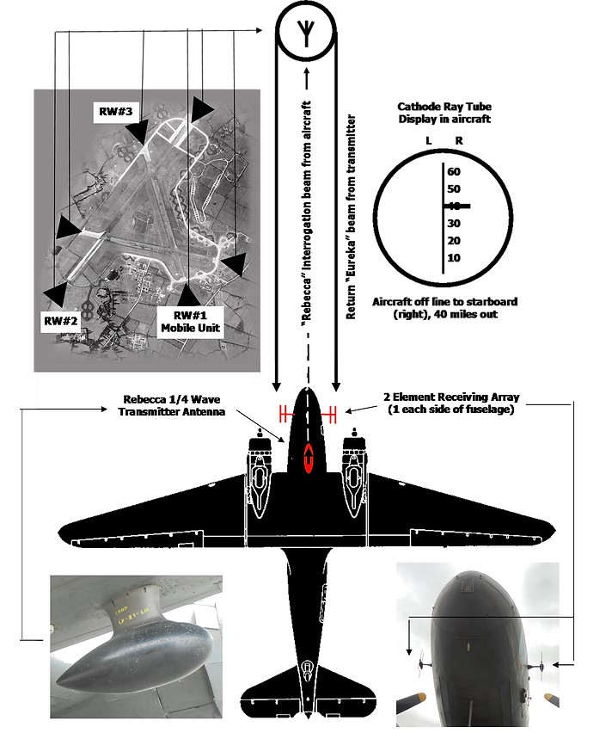

March 24th (Fri.)
In Oxford to Gosport mng - pick up logbooks - "Firebrand", "Avenger" etc Torpedo Development Unit - Blakehill Farm. In aft - Netheravon (simulated droppings) - Gosport - Hurn - Base. pictures night "Okay for Sound".

March 25th (Sat.)
- day off - lovely day - Swindon in aft. show - Rlwy and pub in Old Town - bus back Cricklade.

March 26th (Sun.)
great day - formation (sqdn) in aft. - (simulated droppings) -

March 27th (Mon.)
To Cottesmore to collect 300 paratroops (l5 a/c) To Netheraven D.Z. - dummy run - 2 sticks 5, 1 of 10 paratroops - Netheravon for lunch - troops back to Cottesmore - chutes to Netheravon - tea - looked over Stirling - back Blakehill Farm. Cricklade night - Jim, Bob, Harold.

March 28th (Tues)
Fine day - "Oxford" trip in aft. - went to Brighton.

March 29th (Wed.)
Foggy - no flying - Cricklade at night pubs shut.

March 30th (Thurs)
- 1 Rebecca trip -Cricklade Jim, Bob, Harold - couple beers.

March 3lst (Fri.)
48 for our crew - Oxf. trip (instructor) mng. 2.28 train from Swindon - Paddington 4.30. R.J. - Garrick Hotel - pubs - Don Shake, Down Ampney) - N.Z. obs. & cobber Alec - Rickie & WAAF - more pubs - missed Don, Alec; Chandos - Penny - Grand Hotel Russel Sq.

April lst (Sat.)
Bank - pubs - lunch - "Ali Baba & 40 Thieves" - met Jim Taylor in Forces Club Long Bar - Mitre - tube Jack Fuller on survivor's leave - shot down - Frank Wilson gone west) - Frank Beary in tube - East Finchlay - pub then another - ("xxx") ("xxx") ("xxx") - darts, etc.

April 2nd (Sun.)
12.30 train - camp 3.30 - cold.

April 3rd (Mon.)
Raining - no flying.

April 5th (Wed.)
To Swanston Morley, Norfolk - stayed night (saw the rete (sp?) Aussie).

April 6th (Thurs.)
Back with glider in aft.

April 7th (Fri.)
Nothing doing - pictures night.

April 8th (Sat.)
Nice day - day off. Swindon with Bob, Jim, Harold & Gordon (N.Z. wag)- slow - couple beers - bus back.
April 9th (Sun.)
night flying A5 - A6 - balls up.

April 10th (Mon.)
Rebecca Trip aft. - Bell Inn with Harold night - closed - Cricklade - Jim - Bob - Gordon.

April 11th (Tues.)
pictures Will Hay "Ask a Policeman" night flying scrubbed.

April 12th (Wed.)
To Pershore aft. to collect kite - saw Al Borrie, Ron Halliday - Ron hasn't flown yet. - very cheesed.

April l3th (Thurs.) - l4th (Fri.)
To Cottesmore - Buckminster (RV) - DDZ - landed Church Lawford (AFV) for tea - booze for own mess - back Blakehill F'm - pictures night (Jack Holt).

April l5th (Sat.)
Rehearsal for ex "MUSH" inaft - 22 a/c - Don Sisley - map reader. Times O.K.

April l6th (Sun.)
Cricklade night Jim, Bob, l cider - Harold to Netheravon.

April l7th (Mon.)
nothing done.

April l8th (Tues.)
A.11. nav. trip O.K. - Harold back - posted Doncaster - Cricklade - walk to factory -

April l9th (Wed.)
Rebecca test.

April 20th (Thurs.)
Jim, Bob, Bill Farquarson back from hectic 48 in London - over new D2 in mng. - compass swing aft.

Compass swing at BHF central ‘fry pan’ dispersal 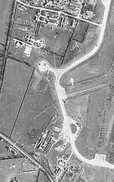

April 2lst (Fri.)
"Mush" - 12 paratroops and their equipment - 48 hr. leave - trip to Hendon - Strand Palace - "Rigoletto" at night with Aunt.

April 22nd (Sat.)
met Gordon Hudson in Lloyds' Bank - few pubs - Chandos - for lunch - (Penny!) Mitre - Aussie - ("xxx”) John (x1) Ian (*) - to Victory Inn, l44 Ben Johnson Rd., Stepney E.1. - drinking all afternoon till 11 - Barb. & I games with kids outside - taxi to Leicester Square ("xxx") ("xxx") - "Osborne" - Russell Sq.

April 23rd (Sun.)
12.30 train to Swindon - out camp - briefed for op. scrubbed because of weather at last minute.

April 24th (Mon.)
- 2 air-tests - nickelling at night between Caon and Bayeaux.

NICKELLING – the act of distributing propaganda leaflets from aircraft

April 25th (Tues.)
Swindon bought bike - nice day -

April 26th (Wed.)
lovely day - Netheravon for pannier dropping - bit tan up - Down Ampney night saw Gruson, McKenzie McCashin, Shannon etc.

April 27th (Thurs.)
Sunbathing - container dropping in aft. local D.Z. Cricklade in morning - cabled Anne. - Ashton Keynes with Cliff Williams at night on bikes.

April 28th (Fri.)
Flip with "Smudge" Smith in mng. Nav. trip night.

April 29th (Sat.)
Dakota in aft. to Pershore - took bike. Ron & Neil on leave - Al Borrie just leaving fr Hurn. Saw Ron Wolles - English W/A/G ex Broadwell. Rode to Worcester. Crown Inn. Pubs - 2 Canadian WAGs Yanks etc. Vic. etc (3) Countryside between Pershore and Worcester very lovely. Worcester a nice old town - bags Tudor-type houses - nice cathedral.

April 30th (Sun.)
Left about 10.15 am - lovely day - down through Tewkesbury to Cheltenham - looked up Mum's cousin Jim - out in London but Mrs Robertson and another lady there - very nice - on through Cirencester to Blakehill Farm.

May 1st (Mon.)
Took Air Vice Marshall to Bicester - pubs - Ashton Keynes - Upper Siddington, Al Woods, Dave Carr.

May 2nd (Tues.)
1.10 pm train to London - "Garrick" - Forces Club - drinking with Bernie N.Z.er OCTV from Cassino - Met Gordon MacKenzie and his brother Dave.

May 3rd (Wed.)
- met Mac & brother in club - drinks - Garrick Hotel - Bernie, Frank Gillett - few civilians - Chandos - Tivoli - Sherry - amusement place - Russell Sq. steak & chips - few drinks night - amusement place - Paddington Swindon to Cricklade in Cliff Williams'

May 4th (Thurs.)
nothing doing -

May 5th (Fri.)
Cirencester & back on bike - flying night n container dropping ex - went O.K.

May 6th (Sat.)
Down Ampney mng. for briefing (went in sqd'n form'n wizard landing 7 kites together on runway - back in CO's car calling at "White Hart" - transport to Down Ampney night there.

May 7th (Sun.)
- dropped l9 Polres on ex. O.K. - off to London 10.25 train - drinks with sailor - met Ray Hansen - Club! put up blacks galore - pubs night. Tivoli shut - could not get Sherry - (Tanks & Mary:)! Chandos etc.

May 8th (Mon.)
Back 10.45 train to Swindon. Semple back from Halton - flew to D.Z. of other night to look for containers. one stick 11 paratroops killed last night - dropped at only l00' by 271 squdn. - letters at night.

May 9th (Tues.)
Marvellous day - bike ride to Crudwell - Kemble - Ewin - Somerford & Ashton Keynes - Cricklade & Ashton Keynes at night with George Coppel - couple beers.

May 10th (Wed.)
Trip with S/Ldr Wright in (?). - sqdn to Down Ampney - beer - tea. Terry, Jack, McKenzie, Doug, Bill G. etc. - show - concert very good (says Bill Bush killed in crash)

May 11th (Thurs.)
TO. 0119 Dropped 5 Poles 0300 - sleep - Left about 12 with Cliff Williams in car for London - via Hungerford, Newbury, Reading, Maidenhead, Slough - hood back - lovely day - tube to Picc. Circus - bank - Kings Cross - show - Andy Hardy - pubs - saw "Old Curiosity Shop". Tivoli - "Hazel" - Russ Sq.

May 12th (Fri.)
Couple beers - lunch - Hampstead Heath (sunbathe) - club met Claude Pocock & observer Skeet - saw Jack Braddock - pubs - stopped me from catching train - Strand Palace.

May 13th (Sat.)
chicken at Silbers - drinks met Rex Beach - Garrick - Rex to camp - out to Stepney "Mas'". Don Sisley & other N.Z.ers too. Dogs at Hackney - lost - pub - Kings Cross - train - sailors - beer.

May 14th (Sun.)
Aberdeen 12.10 taxi to Seafield Cres. - Janet - Aunt at Kirk - dinner - to Irvine Place - 6 Desswood Place.

May l5th (Mon.)
Desswood in mng - bought beer after lunch - Bunt to Newishow Co-op stores with Aunt (Jim Cowie & wife) Gerts for tea - Bunt, Janet, Aunt - 3 of us to pub at Cults via Shakin Brigzie of Dec) walk home.

May l6th (Tues.)
Irvine Place for fly-cup with Aunt Eva. Desswood Place for tea - rummy - nice evening - after tea - with Mr Mackie to Hazlehead - lovely flowers - maze -
May l7th (Wed.)
Met Aunt Amy 11.30 top Holborn St., walk - houses where Dad born, lived etc. Victoria Pk - lovely in sun. Desswood Place for while in aft. Left 6.5 pm train - Gert, Uncle, Bunt, Amy, Eva, Janet saw off.

May l8th (Thurs.)
Arrived Kn'g St about 8 - bus to Charing X - breakfast in "Garrick" Base P/O Hicket for operas - clean up. - aft "Rigoletto" - night "Barber of Seville" - pubs ("xxx") - Garrick.

May 19th (Fri.)
9.5 train to Swindon. - glider towing (mass) in aft - letters night.

May 20th (Sat.)
Glider - towing (mass) - letters.

May 21st (Sun.)
Ex. l5 gliders on Netheravon - party in mess at night - bang on food - tie cutting.

May 22nd (Mon.)
Collected glider from Netheravon - Cirencester in aft. Sonia Henie pictures C. Defense club - beer - snooker - pubs on way home.

May 23rd (Tues.)
Thornaby and back - Ashton Keynes night with Keith Dober. -

May 24th (Wed.)
compass swing - Yatesburgh Hosp.- dentist - Ashton Keynes with Dober, Coppel, Ron Hynes - "Horse & Jockey", "White Hart" - dance - camp -

May 25th (Thurs.)
- Hosp - bath - shave etc - Rain - letters.

May 26th (Fri.)
Purton night with Keith.

May 27th (Sat.)
Lovely day - sunbathed - nicely burnt - Ashton Keynes - cider - camp

May 28th (Sun.)
Another perfect day - Bibury in aft. - very lovely village - aft. tea there with Keith Dober at "Pigeon Farm". -

May 29th (Mon.) (Whit Mon.)
Lovely morning and aft. - nice tan. In aft. to Braydon Pond - swim - thunderstorm.
Ashton Keynes night - Joe Smee Ilraith (sp?) "Plough Inn" - "Dingle" (Ingleby) - Bill Hunter, Joe Procter - drinking till about 4-30 am ("xxx") ("xxx"). Dicy ride home.

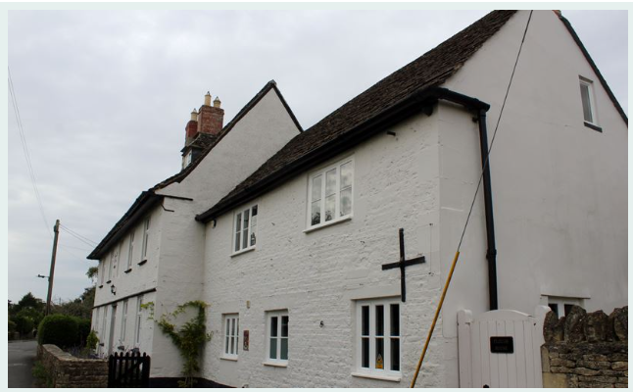

Homestead, public house since before 1867. 1694 TEB on datestone. Colourwashed roughcast on stone and with stone quoining. Stone slate roof. Two storeys and attic, 5 x 2 bays with right extension of further 2 bays. C20 rear addition. Central pair of doors and C20 canopy, blind window over. C19 timber cross windows with painted stucco surrounds. Two stacks to central back to back fireplaces. Wide sprocketed eaves and roof hipped left, and with 2 small hipped dormers. Extension also colourwashed with stone slate roof, and C20 ground floor windows. Building said to have once been a candle factory. Long range of stables and outbuildings to rear. 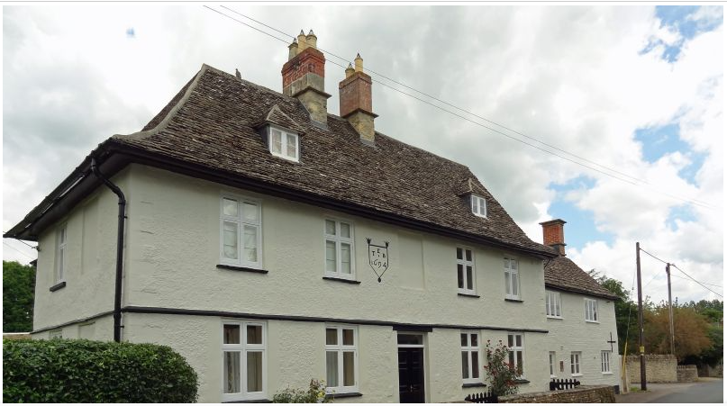

May 30th (Tues.)
Beautiful weather again- swim in aft. - Braydon Pond - Ron Hynes, Keith - took Mae Wests. Ashton Keynes night - couple half pints.

May 31st (Wed.)
Fine in parts - Pond aft. - terrific thunderstorm. Some wizard characters round here - "Joe's father" - an old dirty hobo, Keith & I have seen a few times on the roads round here - last night coming home from Ashton Keynes - a drip shadow boxing fast & furious with the gnats in the middle of the road - wild look in eyes - low amorous bitch at Ashton Keynes always fooling with Yanks, a horrible looking blonde with specs. - silly batwoman & their RAF Reg. Cpl. (Fluff - Audry - Betty).

June lst (Thurs.)
poor day - Cirencester to see show in aft. with Carr, Dobey, Smee.

June 2nd (Fri.)
Fairly fine - air test mng - Confirmed camp -

June 3rd (Sat) - June 4th (Sun)
Briefings for 2nd "Clag" - Raining

June 5th (Mon.)
All set. don't give a damn what happens to me if our part job done O.K. T.O. 2250 via Littlehampton and sea pos'n to D.Z. near Caen. Leading aircraft lst of 6 with gliders containing jeep & trailer (with T.N.T. for bridges) & 2 motorcycles) 37 others with paratroops. Dropped O.K. Lancasters (100) bombed ahead - fair bit flak. some tracer between us & glider.
F/O Harvey Jones (F/O Williams obs. Johnny Doldorph 2n pilot) & W/O McConnell & crew missing - 3 a/c V/S. 2 hit but serviceable. l paratroop killed by flak.

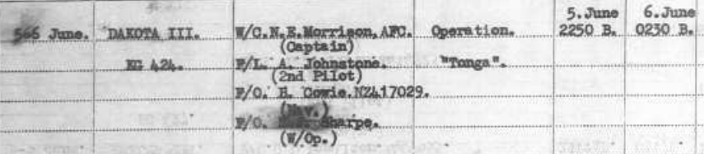

June 6th (Tues.) 1944.
briefing.
